

Dear Doctor,

Happy **VALVEntine's Day**. Please select from the content below to build your very own personalized **Valventine's Day** Facebook posts. This can be posted through your own Facebook account or your clinic’s.

Simply select your preferred messaging and image from the options below to get started.

# OPTION 1:

Copy and paste this message for your post:

This #VALVEntinesDay, ask us about getting a quick and painless heart valve screening. It’s the best way to catch #HeartValveDisease, before it gets worse. Learn more at BeMyValventine.com

Upload one of the following images for your post:

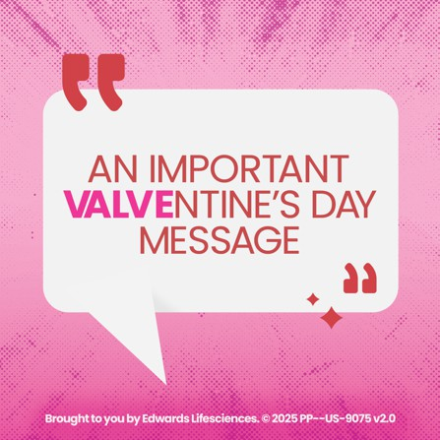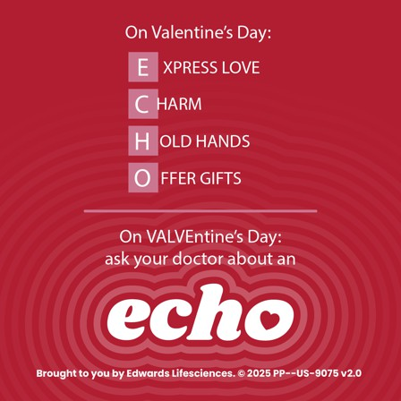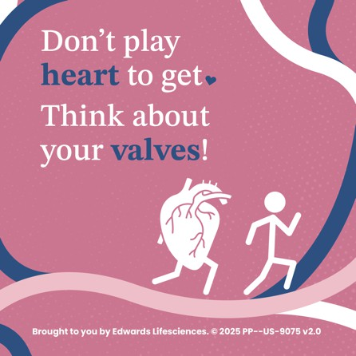



# OPTION 2:

Copy and paste this message for your post:

Celebrate #VALVEntinesDay by making a routine appointment to have your heart listened to and ask us about getting a quick and painless heart valve screening.

Learn more at BeMyValventine.com

Upload one of the following images for your post:

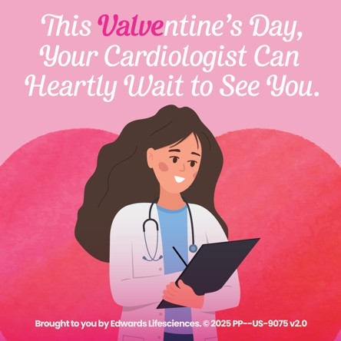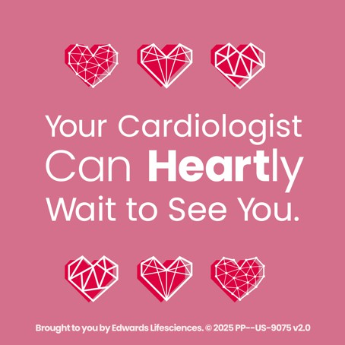

# HASHTAG SUGGESTIONS:

This Heart Month, for any additional Facebook posts about heart valve health, consider including the hashtags below. We have already applied some of them directly to our copy, for your convenience:

**#BeMyValventine #VALVEntinesDay #HeartValveDisease #HeartValveDiseaseAwarenessDay**

Brought to you by Edwards Lifesciences.

© 2025 Edwards Lifesciences Corporation. All rights reserved. PP--US-9075 v2.0