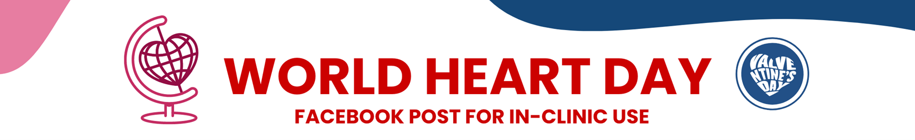

**Dear Doctor,**

Happy **World Heart Day**. Please select from the content below to build your very own personalized **Valventine** emails to share with appropriate patients. Feel free to include one of the attached images as well!



**SUBJECT LINE OPTIONS:**



Choose one of the 3 options below to use as your subject line.

**Option 1:**

World Heart Day is just days away

**Option 2:**

Happy, Healthy World Heart Day!

**Option 3:**

On World Heart Day, show your heart valves some love.

**HEADLINE OPTIONS:**

Choose one of the 3 options below to use as the headline to your email.

**Option 1:**

**WHAT ARE YOUR PLANS FOR WORLD HEART DAY?**

**Option 2:**

**A SPECIAL ANNOUNCEMENT FOR WORLD HEART DAY**

**Option 3:**

**HAPPY WORLD HEART DAY!**







**BODY COPY OPTIONS:**

Choose one of the 3 options below to use as the body of your email.

**Option 1:**

September 29 is **World Heart Day**—a special day to think about your heart valve health and show your valves some love. That means getting educated about heart valve disease and planning to **screen your heart valves, especially if you are 65 years or older**. You can detect heart valve disease by screening your heart valves before it worsens!

**Option 2:**

In honor of this year’s World Heart Day, every day is now Valventine’s Day. And what a perfect time to send a **Valventine’s Day** card to family and friends! Sending a love letter about the importance of screening for heart valve disease can save lives, and that's enough reason to celebrate again and again.

Visit [BeMyValventine.com](http://bemyvalventine.com/) to learn about heart valve disease and **why you should be treating your heart valves to a routine screen, especially if you are 65 years or older.** Early detection and timely treatment can save lives!

**Option 3:**

**World Heart Day** is a perfect time of year to think about your heart valve health and keeping heart valve disease in check. Show your heart valves some love by learning the ins and outs of heart valve health and, **if you are 65 years or older, ask your doctor for a routine screen.** Your heart valves will thank you.





**CALLOUT OPTIONS:**

Choose one of the 3 options below to use as the callout of your email.

**Option 1:**

Heart valve disease affects more than 11 million people in the US. Left untreated, heart valve disease can reduce your quality of life and become life-threatening.

**Option 2:**

Heart valve disease is responsible for nearly 25,000 US deaths annually.

**Option 3:**

Even though it kills so many, 3 out of 4 Americans know little to nothing about heart valve disease.



**CALL TO ACTION COPY OPTIONS:**



Choose one of the 3 options below to use as a next step for your patients to take.

**Option 1:**

**Promise to make heart valve health a priority.**

[Get started](http://bemyvalventine.com/).

**Option 2:**To learn more about heart valve disease and what you can do to stay heart valve healthy, visit [BeMyValventine.com](http://bemyvalventine.com/)

**Option 3:**

Want to learn more about heart valve disease?

[Get the facts](http://bemyvalventine.com/).



**IMAGE OPTIONS:**



Choose one of the 2 images below to attach or embed in your email.

**Option 1:**

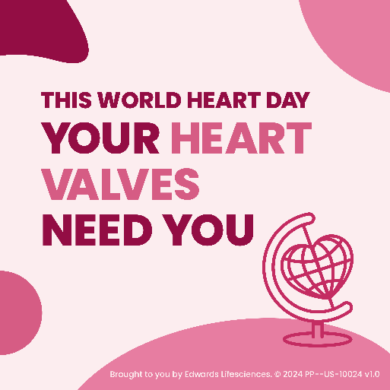

**Option 2:**

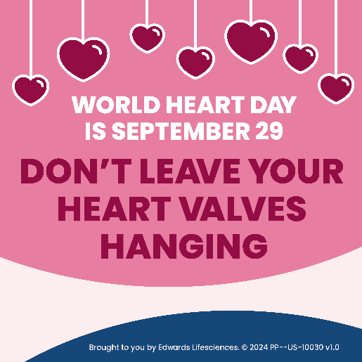





**FOOTER COPY:**

Brought to you by Edwards Lifesciences.

© 2024 Edwards Lifesciences Corporation. All rights reserved. PP--US-10158 v1.0