

Dear Doctor,

Happy **VALVEntine’s Day.** Please select from the content below to build your very own personalized **Valventine’s Day** emails to share with appropriate patients. Feel free to include one of the attached images as well!



**SUBJECT LINE OPTIONS:**

Choose one of the 3 options below to use as your subject line.

**Option 1:**

VALVEntine’s Day is just days away

**Option 2:**

Happy, Healthy VALVEntine’s Day!

**Option 3:**

A day to celebrate heart valve health

**HEADLINE OPTIONS:**

Choose one of the 3 options below to use as the headline to your email.

**Option 1:**

**WHAT ARE YOUR PLANS FOR VALVENTINE’S DAY?**

**Option 2:**

**AN IMPORTANT VALVENTINE’S DAY MESSAGE**

**Option 3:**

**HAPPY VALVENTINE’S DAY!**



**BODY COPY OPTIONS:**

Choose one of the 3 options below to use as the body of your email.

**Option 1:**

February 22 is **VALVEntine’s Day**—a special day, in the heart of Heart Month, solely dedicated to heart valve health and showing your valves some love. That means getting educated about heart valve disease and making a plan to **screen your heart valves, especially if you are 65 years or older**. By screening your heart valves, you can catch heart valve disease before it gets worse!

**Option 2:**

Honor your heart valves this February 22, a special time of year dedicated to heart valve health. Some people call it Heart Valve Disease Awareness Day. We call it **VALVEntine’s Day**.

To celebrate, visit [BeMyValventine.com](http://bemyvalventine.com/) to learn about the deadliness of heart valve disease and **why you should be treating your heart valves to a routine screen, especially if you are 65 years or older.** Early detection and timely treatment can save lives!

**Option 3:**

Introducing a time of year dedicated to heart valve health and keeping heart valve disease in check. This **VALVEntine’s Day** (February 22), show your heart valves some love by learning the ins and outs of heart valve health and, **if you are 65 years or older, asking your doctor for a routine screen.** Your heart valves will thank you.

**CALLOUT OPTIONS:**

Choose one of the 3 options below to use as the callout of your email.

**Option 1:**

Heart valve disease affects more than 11 million people in the US. Left untreated, heart valve disease can reduce your quality of life and become life-threatening.

**Option 2:**

Heart valve disease is responsible for nearly 25,000 US deaths annually.

**Option 3:**

Even though it kills so many, 3 out of 4 Americans know little to nothing about heart valve disease.



**CALL TO ACTION COPY OPTIONS:**

Choose one of the 3 options below to use as a next step for your patients to take.

**Option 1:**

**Help raise awareness for heart valve health**

Make a **VALVEntine’s Day** promise and send a **Valventine’s Day** card to family and friends. [Get started](http://bemyvalventine.com/).

**Option 2:**To learn more about heart valve disease, and what you can do to stay heart valve healthy, visit [BeMyValventine.com](http://bemyvalventine.com/)

**Option 3:**

Want to learn more about heart valve disease?

[Get the facts](http://bemyvalventine.com/).



**IMAGE OPTIONS:**

Choose one of the 2 images below to attach or embed in your email.

**Option 1:**

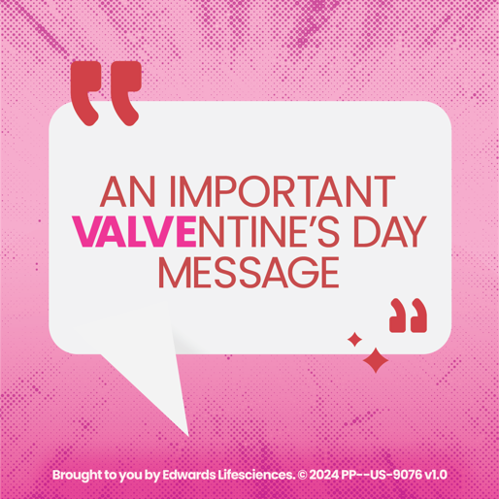

**Option 2:**

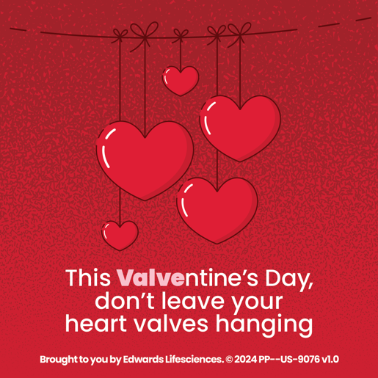



Brought to you by Edwards Lifesciences.

© 2024 Edwards Lifesciences Corporation.

All rights reserved. PP--US-9076 v1.0