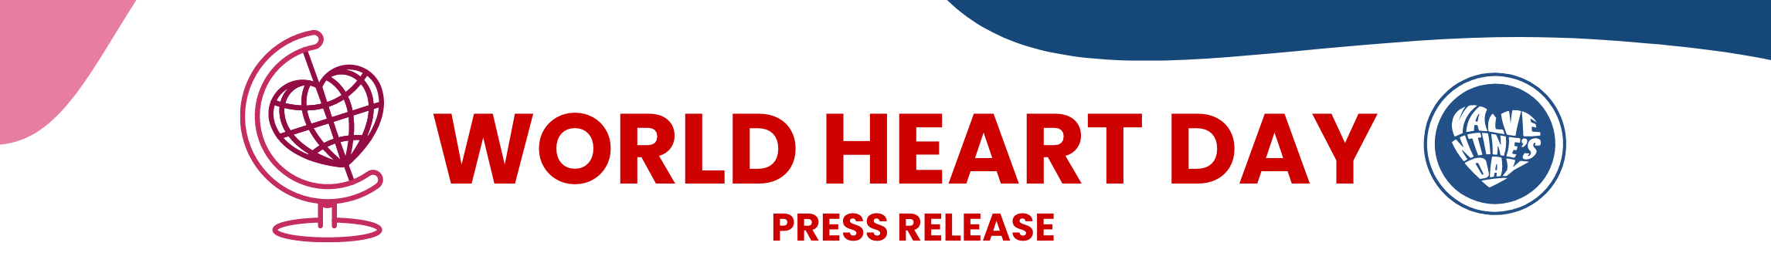

[headline]
WE'RE PART OF A GLOBAL EFFORT TO GET THE WORD OUT ABOUT HEART VALVE HEALTH

[copy]
Heart valve disease affects more than 11 million people in the US, yet most know little to nothing about it.

To help raise awareness for the importance of heart valve screenings, we are joining Edwards Lifesciences in celebrating World Heart Day on September 29.
Why does heart valve health matter?

- Heart valve disease is responsible for over 25,000 US deaths annually
- Although heart valve disease is more common in people older than 65, it can happen at any age
- Black Americans may be at increased risk for earlier onset of heart valve disease—and women are being diagnosed much later than men
Join us in giving this important part of the heart the lifesaving attention it deserves by visiting BeMyValventine.com for ways to participate. Valventine’s Day in September? That’s right. In honor of World Heart Day, every day is now Valventine’s Day. It’s our heartfelt gift to the global community.
Wishing you well,

[HOSPITAL NAME]

[visual—hospital logo]

Brought to you by Edwards Lifesciences.
© 2024 Edwards Lifesciences Corporation.
All rights reserved. PP--US-10026 v1.0

